Type your paper title here
Firstname Middlename LASTNAME¹, Firstname Middlename LASTNAME²,
and Firstname Middlename LASTNAME^{1,*}
¹University/Institute Mailing Address, Street/Road, City/Province, State, Zip Code, Country
²University/Institute Mailing Address, Street/Road, City/Province, State, Zip Code, Country
*Corresponding author e-mail: example@domain.ac.th, Phone: +xx (0) xxxxxxx,
Fax: +xx (0) xxxxxxx

Abstract
Insert your abstract here covering some short descriptions of motivations, research procedure, results, and conclusions (maximum length 200 words).

Keywords: …………….; …………; ………….; …………. (3-5 keywords)

1. Introduction
2. Experimental
2.1 Subsection
Type your text here.
Equation examples:
y = mx + c (1)
E = mc² (2)
3. Results and discussion (Results section and Discussion section may be separated)

Figure 1.

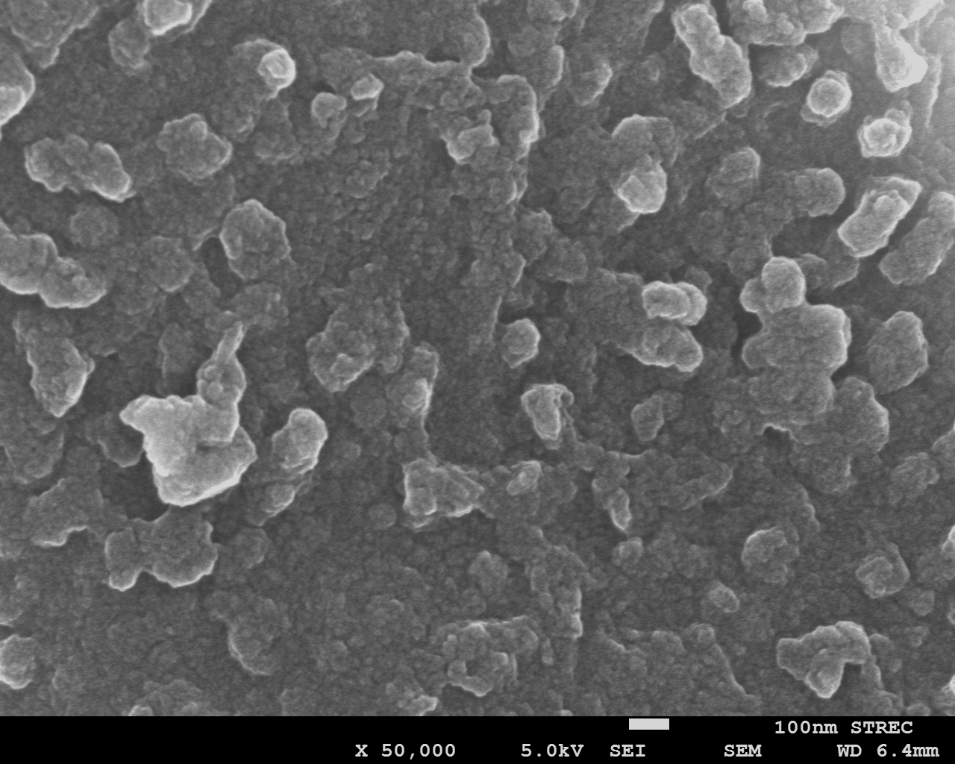
Figure 2.

Tables (examples)
Reinforcement type | Composition (%)
 | A | B | C | D
X | 36 | 15 | 23 | 26
Y | 45 | 28 | 12 | 15
Z | 18 | 49 | 6 | 27

Table 1

Reinforcement type | Crystallinity (%)
X | 78
Y | 59
Z | 83

Table 2

4. Conclusions
5. Acknowledgements

In-text citation example:
‘…..good insulators [8]. Rowell [9] has reported that…..’ and ‘…..examined [10]. Du et al. [11] treated fibres at…...’

References (examples)
[1] B. F. Abu-Sharkh and H. Hamid, "Degradation study of date palm fibre/polypropylene composites in natural and artificial weathering: mechanical and thermal analysis," Polymer Degradation and Stability, vol. 85, pp. 967-973, 2004. (Reference to a journal)
[2] I. M. Daniel and O. Ishai, Engineering mechanics of composite materials. New York: Oxford University Press, Inc., 1994. (Reference to a book)
[3] A. Dufresne, "8 - Cellulose-Based Composites and Nanocomposites," in Handbook of Biopolymers and Biodegradable Plastics, ed Boston: William Andrew Publishing, 2013, pp. 153-169. (Reference to a chapter in an edited book)

* Total word count for a regular manuscript needs to be between 2,500-6,000
* Total word count for a review manuscript needs to be between 3,000-10,000

For more information, please see JMMM manuscript submission guidelines.

